PROJECT SYNOPSIS

##### **On**

**AgroSeed**

**Towards partial fulfillment of the requirement**

**For the award of degree of**

###### **Bachelor of Computer Applications**

**From**

# Babu Banarasi Das University

**Lucknow**



**Academic Session 2019 - 20**

### School of Computer Applications

Submitted by: Under Guidance of: Mr. Mirza

|  |
| --- |
| **I Floor, H-Block, BBDU,BBD City, Faizabad Road, Lucknow (U. P.) INDIA 226028**  **PHONE: HEAD:** 0522-3911127,3911321**Dept. Adm. & Exam Cell:** 0522-3911326**Dept. T&P Cell:** 0522-3911305; **E-Mail:** head.sca@gmail.com |
| [**www.bbdu.ac.in**](http://www.bbdu.ac.in) |

**TITLE OF THE PROJECT**

An introduction to​**“AgroSeed”:** ​In this project we will provide an easy access to farmers for all the information required for the crop development like soil description, crop description, and type description to choose from best and apply best. Our system will also allow them to send messages for any other queries which are not there in the portal or which he is not able to access.

***Agriculture is the backbone of the Indian Economy"- said Mahatma Gandhi six decades ago.***

Even today, the situation is still the same, with almost the entire economy being sustained by agriculture, which is the mainstay of the villages. It contributes 16% of the overall GDP and accounts for employment of approximately 52% of the Indian population. Rapid growth in agriculture is essential not only for self-reliance but also to earn valuable foreign exchange.

Indian farmers are second to none in production and productivity despite of the fact that millions are marginal and small farmers. They adopt improved agriculture technology as efficiently as farmers in developed countries. It is felt that with provision of timely and adequate inputs such as fertilizers, seeds, pesticides and by making available affordable agricultural credit /crop insurance, Indian farmers are going to ensure food and nutritional security to the Nation.

Once logged in the Farmers’ Portal, a farmer will be able to get all relevant information on specific needs on land, crops etc. Nearest soil test center location can easily be reached through the Map of India placed on the Contact page. Farmers will also be able to ask specific queries as well as give valuable feedback through the message column.

**Company Profile**



**Infoseek Software Systems Pvt. Ltd.**

**18 Chandganj Garden, Kapoorthala Aliganj,**

**Phone no: (0522 400 1372) Lucknow - 226024.**

**Email: info@infoseeksoftwaresystems.com**

**About Infoseek Software Systems:**

Infoseek was founded in the year 2004, by a fresh graduate who quitted his job from Skype and started this company with 2 employees from a one room office in Lucknow. Infoseek’s objective is to combine creativity and experience to develop and deliver quality information solutions. Infoseek has always been at the leading edge of driving innovation in the offshore development industry. Our record is at adding value to our services through reduced time to market, high quality, and technologically innovative processes. Satisfied clientele across the globe bears testimony to the quality and reliability we provide at competitive costs.

Being an offshore development company, we recognize the need for our employees to be proficient with communication, working in close collaboration with offshore clients. We hire qualified professionals from reputed engineering and management institutions with proven records of software development. The work platforms are maintained using expert professional advice to help the team deliver accurately.

Infoseek has a well-knit team comprising of over 50+ self-motivated professionals including Project Managers, Programmers, iPhone Developers, Android developers, Blackberry Developers, Web Developers, Graphic Designers, Online Marketing Professionals, SEO guys, and Webmasters to take care of development and maintenance of projects.

**Technologies we work on:**

**Languages: PHP 5, PHP 4, JAVA, Android, Python, Data Science, SAP, Digital Marketing, IOT, Big Data, Hadoop.**

**Microsoft Technologies: C#, VB.NET, Visual Studio .Net 2003/2005/ 2008, SharePoint services 3.0, MOSS 2007, MOSS 2010, ASP.**

**IPhone, Mobile & Handhelds: Apple iPhone development using Xcode and Objective C, Blackberry, Google Android, Microsoft Windows Mobile, J2ME Windows7 Phone, Android tablet.**



**Software Requirements:**

|  |  |  |
| --- | --- | --- |
| **Web Presentation** | **:** | **HTML, CSS, Bootstrap** |
| **Client Side Scripting** | **:** | **JavaScript** |
| **Programming Language** | **:** | **Java** |
| **Web based Technologies** | **:** | **Servlets, JSP** |
| **Database Connectivity** | **:** | **JDBC** |
| **Java Version** | **:** | **JDK1.8** |
| **Backend Database** | **:** | **My SQL 5.5 or higher** |
| **Operating System** | **:** | **Windows XP or Higher** |
| **Web Server** | **:** | **Tomcat 7.0 or Higher** |
| **Web Browser** | **:** | **IE/Mozilla/Chrome** |

**Hardware Requirement:**

**Client-Side:**

|  |  |  |  |
| --- | --- | --- | --- |
| **Browser** | **Processor** | **RAM** | **Disk Space** |
| Internet Explorer 6.0 | Pentium-4 | 512MB | 4GB |
| Or Higher | or Higher |  |  |
| **Server-Side:** |  |  |  |
| **Browser** | **Processor** | **RAM** | **Disk Space** |
| Apache Tomcat | Pentium-4 | 512MB | 32GB |
| Or Higher | Or Higher |  |  |
| Oracle 9i | Pentium-4 | 512MB | 32GB |
| Or Higher | Or Higher |  |  |

# PROJECT TEAM

The following project consists of four Respective members, who were equally involved in the completion of the Project

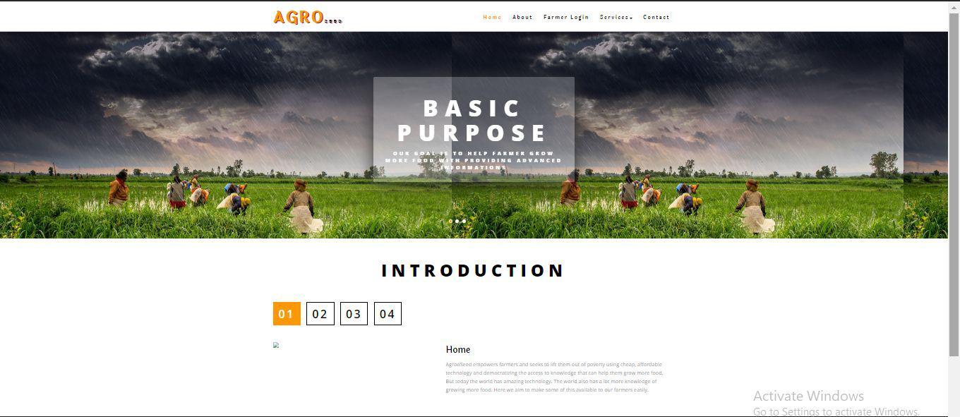

# PROJECT SCHEDULE & PLAN

The following project was started from the beginning of January 2020 and is completed by the end of April 2020.

|  |  |  |  |  |  |  |
| --- | --- | --- | --- | --- | --- | --- |
| Task | 4 jan-30 Jan | 31 Jan-9 Feb | 10 Feb-12 Mar | 13 Mar-16 Apr | 17 Apr-22 Apr | 23 Apr-28 Apr |
| Develop Project  Proposal | 27 Days |  |  |  |  |  |
| Analysis |  | 10 Days |  |  |  |  |
| Designing |  |  | 30 Days |  |  |  |
| Coding |  |  |  | 34 Days |  |  |
| Unit Testing |  |  |  |  | 5 Days |  |
| Implementation |  |  | .. |  |  | 5 Days |

# PROCESS DESCRIPTION

AgrooSeed is a website which will provide an easy access to farmers for all the information required for the crop development like soil description, crop description and type description to choose from best and apply best. Our system will also allow them to send messages for any other queries which are not there in the portal or which he is not able to access.

For Admin side he will be having full access to the registrations, messages and the website database information. He can add, view, and delete anything he wants. The admin is required to be pre-logged in to access everything.



### Product Perspective

**Purpose:**

Indian farmers are second to none in production and productivity despite of the fact that millions are marginal and small farmers. They adopt improved agriculture technology as efficiently as farmers in developed countries. It is felt that with provision of timely and adequate inputs such as fertilizers, seeds, pesticides and by making available affordable agricultural credit /crop insurance, Indian farmers are going to ensure food and nutritional security to the Nation. It is a website used for farmers for knowing the information about various crops, and in which soil they grow more, and the usage of fertilizers to the crops. If necessary, messaging system is also provided for them.

**Scope:**

○ providing accessibility to all users who have a valid user ID and password.

○ generating updated information regarding crops, types and soil for best output

○ User can message query and can get answers accordingly.

○ Phone numbers of the website managers are also given with the location of the nearest agriculture centre.

▪Users of the system: o Farmers

o Administrator

o Agricultural officers

**Features of the Site**

* Farmers can use the portal for getting the knowledge and guidance about which crop to grow according to soil and monsoon and all the important ingredients for best crop production like fertilizers, pesticides, water requirement etc.
* The information should not be accessed by an unauthorized person and only the admin can make all the changes required.
* In case of any queries the farmer can also contact the admin through messaging provided by portal itself.

This project is helpful in sharing secured information online at any time at any place and at any hour of the day being convenient. The user can sit at home and know all the useful information about his land and crop. It is being able to conduct business in all the 365 days.

**CONTRIBUTION OF THE STUDENT IN THE PROJECT**

1. **Student Name : User services, User registration, User login and authentication, Contact form, Admin login and authentication, View, update and delete registration, View , update & delete website data, View messages**

# CONCLUSION

AgrooSeed is a website which will provide an easy access to farmers for all the information required for the crop development like soil description, crop description and type description to choose from best and apply best. Our system will also allow them to send messages for any other queries which are not there in the portal or which he is not able to access.

For Admin side he will be having full access to the registrations, messages and the website database information. He can add, view, and delete anything he wants. The admin is required to be pre-logged in to access everything.

**Infoseek** **Software Systems Pvt. Ltd**

Under the Guidance of Err. Noman Siddiqui.

We are really thankful to everyone who were there for supporting us,

We sincerely appreciate your efforts.